**Ghulam Qadir Wani**

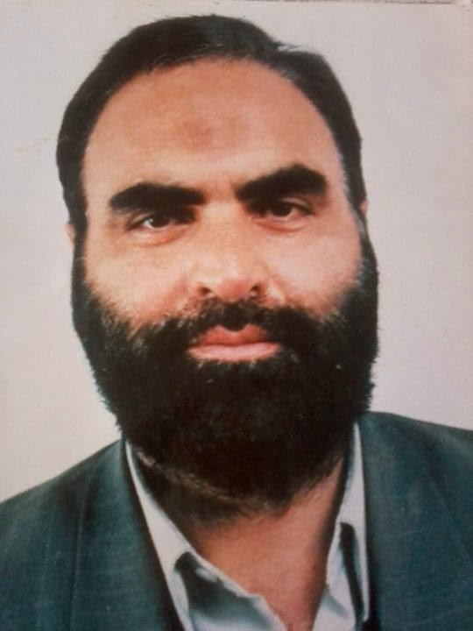

**About:** Ghulam Qadir Wani - a reputed figure, leader, and a scholar was born in Arin village of Bandipora district. He got early education from government school Gamoora. He was taught by one of a leading teacher and saint Usman Fazili. He then joined higher secondary Kaloosa, graduated from Degree College Spore and later joined Jawahar Lal Nehru University in Delhi.

Dr Wani was an institution and used to keep eye on every social, political, local and international issue of the time. Customarily, he was known for his pro-freedom stances and most importantly for internationalizing Kashmir issue. For public he was as a strategist, political activist and a pro-freedom leader but for me he was a philosopher, traditionalist and a man of with high self-esteem. Besides discussing political issues he mostly used to express his esoteric aspiration of seeking absolute truth. He was always striving for higher consciousness. He not only fought for aspirations of Kashmir but tried to devise an impressive and result ordinated philosophy of aspiration based on self-esteem and scholasticism. He used to quote Abul Kalaam Azad very frequently. The first time I heard the name of book “*India Wins Freedom”* was from him only. He was impressed by independent and self-esteemed attitude of Abul Kalam, who according to him made his own way besides being impressed by Jamal-ud-Afghani and Muhammad Abdu.

**Murdered:** 4 November 1998.

### Attack details: On the evening of 4 November 1998 gunmen barged into his house in Arin Bandipora and opened fire at close range. Wani's niece was killed instantly, while the leader succumbed to his injuries on the way to the hospital. His daughter and a servant were Separatist leader, niece killed in Kashmir.

**Reason to him target:** Unidentified militants gunned down Jammu and Kashmir separatist leader Dr Ghulam Qadir Wani and his niece at their Bandipore residence Wednesday evening.

**Occupation:** Dr Wani, Jammu and Kashmir Liberation Front's former publicity chief, was also the founder chairman of the Islamic Students League.

**Belief:** He was of the view that Kashmir could never achieve anything till dogmatic and hired political ideology dominates the scene. I always saw him reciting verses from Quran and preaching ideas of modern philosophers like Sartre, Keirigaard, Voltaire, Gramsci etc.

**Educational details:** Dr Wani completed his Phd from the Jawaharlal Nehru University, New Delhi. He was a leading intellectual of the valley, and widely considered to be a moderate separatist leader.

**Reaction of local population:** He was an intellectual par excellence. He used to say that “Life is life when the esoteric musical strings resonate together with exoteric worldly strings; this common resonance gives meaning to song of life.” He was never silent. He always acted like honest and real intellectual, wherever he used to go he spoke boldly and spoke truth to everyone against oppression and miseries of people.

**URL :** <https://en.wikipedia.org/wiki/Ghulam_Qadir_Wani>

<https://indiankanoon.org/doc/164544247/>

<https://www.greaterkashmir.com/news/kashmir/19-years-on-plotters-of-wanis-murder-still-at-large-family/>

